Tender Specification
Pre-commercial procurement of research and development

Sorting of fines in residual waste and separation of organic waste from residual waste

Websak 23/1243

Innhold
1 Competitive tender for pre-commercial purchase 3
2 Assignment 4
2.1 Tender documents 4
2.2 Contracting Authority 5
2.3 Description of deliverable 5
2.4 Intellectual property rights 5
2.5 Language 5
2.6 Progress plan 5
2.7 Partial tenders 6
2.8 Questions concerning the tender documents 6
2.9 Updating the tender documents 6
2.10 Public disclosure 6
2.11 Rejection 6
3 Background to the project 7
4 RULES FOR ENTERING INTO AND EXECUTING A PRE-COMMERCIAL PROCUREMENT 7
4.1 Selection of idea/concept (phase 0) 7
4.2 Implementation of the research and development project (phases 1-3) 8
4.3 Schedule for implementation of pre-commercial procurement 9
5 QUALIFICATION REQUIREMENTS 10
5.2 Contractor groups and subcontractors 10
5.3 The European Single Procurement Document self-declaration form 11
6 AWARD CRITERIA 11
7 SUBMISSION OF TENDER 12
8 APPENDICES 13

Competitive tender for pre-commercial purchase
This competitive tender shall be conducted as a pre-commercial procurement. The pre-commercial procurement shall be carried out in accordance with the provisions stipulated in the tender documents (see section 2.1).

Pre-commercial procurement is a method proposed by the European Commission for the procurement of research and development services that is carried out in accordance with the exemption provision (Section 2-5) in Regulations No. 974 of 12 August 2016 relating to public procurements. This entails that the Public Procurement Act and Public Procurement Regulations do not apply. Pre-commercial procurement can be used when there is a need to develop solutions that do not currently exist in the market.

The sketch below provides a schematic image of the pre-commercial procurement process:
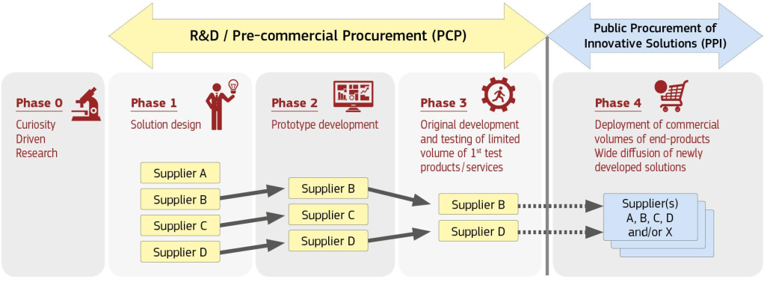

The pre-commercial procurement begins as an idea competition in which the market is invited to solve a specific challenge. The product ideas are evaluated in relation to award criteria (see p.6). IVAR IKS is the client on behalf of the group (see section 2.2) and will enter into research and development agreements with the contractors that have the best proposals. Call-off agreements will be entered into for phases 2 and 3 that are based on the research and development agreement. In total, agreements will be entered into with up to five contractors.

The development process is divided into different phases: phase 1 (preparation of proposed solution), phase 2 (development of prototype) and phase 3 (field testing of the prototype). The development work in the various development processes is evaluated following each phase in relation to the award criteria in the call-off agreements for phases 2 and 3. The best proposed solutions from phase 1 will then be invited to phase 2 (development of prototype). In phase 2, the best prototypes will be invited to proceed to phase 3 (field testing of the prototype).

Call-off contracts will be entered into for the tenderers that proceed to phases 2 and 3. The call-off contracts include the contracting authority’s potential specification of the requirements in appendix 1 and new requirements for the phase, a cooperation and progress plan for the phase and prices. The contract is terminated for the tenderers that do not progress further in the competitive tender. For an overview of the execution of the agreement, see the sketch below:

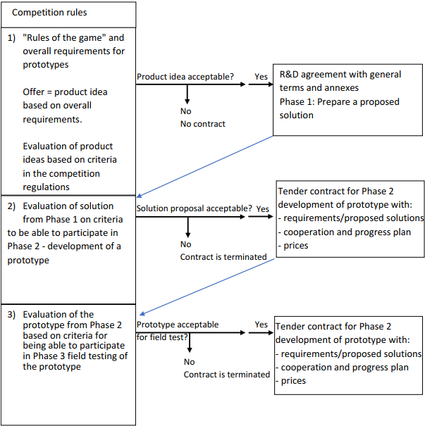

A potential purchase of a solution will be conducted as a separate procurement (commercial procurement), and is not part of this competitive tender. Any commercial procurement will be open to all contractors in the market.
See section 4 of this document for more detailed information regarding how the pre-commercial procurement is conducted.

Assignment

Tender documents
The tender documents consist of two parts:
- Rules of Tender with Appendices
- Research and Development Agreement for Pre-Commercial Purchase

Contracting Authority
The client is a group consisting of the Norwegian waste disposal companies ØAS, ROAF and IVAR, as well as Sesam Ressurs AS and REG. IVAR represents the group when it comes to the announcement of competition and communication in connection with this.

The companies in the group deal with waste management, which includes receiving and sorting waste. Together, these companies are responsible for processing residual waste from approx. 45 percent of Norway's inhabitants.

Today, only ROAF has an operational sorting facility, but the participants have in common that they are considering or have decided to build a sorting facility for residual waste.

Oppdragsgivers kontaktperson er:

Navn: | Kjetil Moen
e-post | kjetil.moen@ivar.no

All contact/communication in this competitive tender shall only take place with the contact person designated by the contracting authority.

Description of deliverable
The Customer's description of the deliverable follows from appendix 1 (Customer's description of needs and requirements for the proposed solution, prototype and field testing) in the Research and Development Agreement for Pre-Commercial Purchase.

Intellectual property rights
The regulation of intellectual property rights is specified in the enclosed Research and Development Agreement for Pre-Commercial Purchase.

Language
All written and oral communication in connection with this competitive tender must be in Norwegian, Danish, Swedish and/or English. The language requirement also applies to the tender itself.

Progress plan
The progress plan for entering into a research and development agreement for pre-commercial purchase is set out in section 4.3 of this document.

Partial tenders
It is not possible to only submit tenders for parts of the assignment.

Questions concerning the tender documents
The contracting authority encourages the contractors to familiarise themselves with the tender documents and to submit questions if anything is unclear. If errors are discovered in the tender documents, it is requested that this be communicated in writing to the contracting authority's contact person.

Any questions that contractors may have regarding the tender documents must be submitted by the deadline in section 4.3.1 of this document. Any questions must be submitted in writing via the tender management tool (KGV). All questions will be responded to in anonymised form and made available to all parties that have expressed an interest in the competitive tender in the tender management tool (KGV).

Updating the tender documents
The contracting authority has the right to make corrections, additions or amendments to the tender documents. If the contracting authority needs to make significant changes, the competitive tender can be cancelled and re-announced.

Any corrections, additions or amendments to the tender documents, as well as questions and responses in anonymised form, will be communicated to all contractors that have been invited to submit tenders.

Public disclosure
Contractors are requested to submit a version of the tender in which the contractor redacts what it considers to be trade secrets. When requesting access, the contracting authority shall, irrespective of this, assess whether the information is of such a nature that the contracting authority is obligated to exclude it from public disclosure.

Rejection

It is not possible to make significant reservations in respect of any the conditions in the tender documents. Tenders which include significant reservations or deviations from the tender documents may be rejected.

The contracting authority may also reject tenders that, due to discrepancies, reservations, errors, deficiencies, ambiguity or similar may cast doubt as to how the tender will be evaluated in relation to the other tenders.

Background to the project

The EU's waste directive requires that Norway must be able to recycle 65% of household waste by 2035. This means, among other things, that 70% of plastic and food waste must be sorted out of household waste by 2035. Analyzes show that only around 40% of this is sorted today.

In order to contribute to this, the client wants to carry out a pre-commercial procurement to find suppliers who can develop good solutions for sorting residual waste, so that a larger proportion of this can be recycled. The challenge is that current equipment and methods are unable to sort out fractions smaller than 60mm in size. As a result, a lot of waste that could have been recycled is incinerated.

RULES FOR ENTERING INTO AND EXECUTING A PRE-COMMERCIAL PROCUREMENT

Selection of idea/concept (phase 0)

The competitive tender process includes the following stages:

- Announcement of pre-commercial procurement
The competitive tender starts when the tender documents have been announced on Doffin (Norwegian national notification database for public procurement). The tender documents consist of the rules of tender and the pre-commercial development agreement (the "agreement") with appendices. The description of needs in appendix 1 to the agreement describes the challenge that the contracting authority wishes to solve and its requirements for the solution. Contractors wishing to commence a research and development process to solve the challenge are encouraged to submit one or more idea sketches for the solution. Only the contractors that satisfy the qualification requirements will have their idea sketches evaluated in the competitive tender. See section 5 for further information regarding qualification requirements.

- Preparation of tender with idea sketch:
Tenderers that wish to enter into an agreement with the contracting authority must prepare an idea sketch based on the tender documents. The idea sketch must be sent to the contracting authority together with the qualification documents and confirmation that the tenderer wishes to participate in the competitive tender by the tender submission deadline.

Tenderers have the opportunity to submit questions regarding tender documents before the deadline for submitting questions expires.

- Evaluation of tender with idea sketch
All tenderers that satisfy the qualification requirements will have their idea sketches evaluated.
Evaluation of the idea sketch will be based on the award criteria in section 6.1.

- Negotiations
Tenderers may be invited to negotiations to clarify and potentially improve their idea sketch, proposed solution, prototype and/or proposal for field testing. It is up to the contracting authority to decide whether or not to conduct negotiations, including how and with whom the negotiations should be conducted in the various phases.

- Signing of agreement
The contracting authority will sign an agreement with the tenderers that are qualified and have the best idea sketches.

Implementation of the research and development project (phases 1-3)
The research and development project shall be carried out with the following phases:

PHASE 1: Development of proposed solution
- Using the idea sketch, the contractor must prepare a proposed solution for a prototype based on the requirements specified by the contracting authority in appendix 1 of the agreement.
- The proposed solution is evaluated as specified in the call-off agreement for phase 2, and the contracting authority will sign the call-off agreements for phase 2 with up to 3 contractors that have the best proposed solutions. For contractors that do not receive a call-off agreement for phase 2, the agreement will be terminated.
PHASE 2: Development of a prototype
- In accordance with the proposed solution, the contractor shall prepare a prototype based on the contracting authority's requirements set out in appendix 1 of the agreement and the call-off agreement for phase 2.
- The prototype shall be evaluated as specified in the call-off agreement for phase 3, and the contracting authority will sign call-off agreements for up to 2 contractors for phase 3 with the contractors that have the best prototypes. For contractors that do not receive a call-off agreement for phase 3, the agreement will be terminated.

PHASE 3: "Field testing of solution"
- In accordance with the prototype, the contractor shall prepare a plan for field testing based on the contracting authority's requirements set out in appendix 1 of the agreement and the call-off agreement for phase 3.

Phase | Duration | Sum (to be shared by suppliers or consortium) | Number of suppliers (or consortium)
1 | 5 months | 800 000 NOK exclusive VAT | 4-6
2 | 14 months | 5, 28 MNOK exclusive VAT | 3
3 | 3 months | 1,2 MNOK exclusive VAT | 2

Schedule for implementation of pre-commercial procurement

Important dates for conducting phase 0
The contracting authority has established the following timeframes for the process :

PHASE 0 – SELECTION OF IDEA/CONCEPT
Activity | Date
Deadline for asking questions regarding the competition | 19. April 2024
Deadline for submitting idea sketch. | 26. April 2024 12:00
Opening of offers | 26. April 2024
Evaluation | Week 18-19
Conclusion of contract | Week 20
Offer’s acceptance period | 2 months after submitting

Please note that the dates following the deadline for submitting idea sketch, are provisional.

Tentative progress plan for implementation of phases 1-3
The contracting authority has established the following timeframes for the process:

PHASE 1 – DEVELOPMENT OF PROPOSED SOLUTION
Activity | Date
Conclusion of contract | Week 20 2024
Final deadline for submission of proposed solution | Week 41 2024
Evaluation of proposed solution | Week 42-43 2024
PHASE 2 – DEVELOPMENT OF A PROTOTYPE
Aktivitet | Tidspunkt
Call-off for phase 2 | Week 44 2024
Final deadline for submission of prototype | Week 51 2025
Evaluation of prototype | 420 days after entering into the call-off agreement for phase 2.
PHASE 3 - FIELD TESTING OF THE SOLUTION
Activity | Date
Call-off for phase 3 | Week 3 2026
Field testing completed | Week 16 2026
Conclusion of pre-commercial procurement | 110 days after entering into the call-off agreement for phase 3.

QUALIFICATION REQUIREMENTS
The contractor's qualifications will be assessed based on the documentation submitted. Only contractors that are found to be qualified will have their tenders evaluated. Fulfilment of the qualification requirements below is a prerequisite for continued participation in the competitive tender.

5.1 The Contractor's registration, authorisation, etc.
Requirements | Documentation requirements
The contractor must be registered in a register of business enterprises, professional register or trade register in the state where the contractor is established. | - Norwegian companies: Certificate of registration.  - Foreign companies: Confirmation that the company is registered in a register of business enterprises, professional register or trade register in the state where the contractor is established.

Selected suppliers must deliver a tax certificate

Contractor groups and subcontractors
If the contractor submits a tender in collaboration with others or intends to use subcontractors when participating in the competitive tender, the contractor must document to the contracting authority that it will have access to the necessary resources by submitting a declaration of commitment.

Should the contractor need to change collaborative partner(s) during the competitive tender, the contracting authority must be informed of this. The contracting authority cannot refuse to accept a change in the contractor’s collaborative partners without reasonable grounds.

The European Single Procurement Document self-declaration form
As preliminary documentation of fulfilment of the qualification requirements and that there are no grounds for rejection, the contractor must complete the enclosed European Single Procurement Document (ESPD) self-declaration form. This form must be submitted together with the request for participation.

The contracting authority may, at any stage of the competitive tender, ask the contractor to present all or part of the documentary evidence if this is necessary for ensuring that the competitive tender is carried out in the correct manner.

AWARD CRITERIA
The contract will be awarded based on the tender that offers the best ratio between price and quality, using the following criteria:

Criteria for entering into a research and development agreement for pre-commercial purchase (all contractors with whom the contracting authority enters into a contract complete Phase 1 – "Development of proposed solution").

Award criteria | Weighting | Documentation requirements
Tenderer's idea sketch  The following factors are assessed under this criterion:  - How well the idea correlates with the contracting authority's description of needs, see Appendix 1. | 70 % | - The contractor's idea sketch and description of proposed solution, see requirements in Appendix 1.
Ability to execute  The following factors are assessed under this criterion:  - Progress plan  - Competence  - Available resources  - References from other projects | 30 % | - Description of the supplier’s resources and their competence to realize the idea.

SUBMISSION OF TENDER
The tender must be submitted in accordance with the design specified in the electronic system for submitting tenders.

Tenders must be submitted with the following content and structure:

Document | Explanation
- Completed European Single Procurement Document (ESPD) self-declaration form. | The contractor must submit a completed ESPD form together with the tender (see section 5.3).  If multiple contractors jointly participate in the competitive tender, the participating contractors must submit separate ESPD forms.
- Letter of tender | The letter of tender must be completed and signed by a person authorised to incur obligations on behalf of the contractor. The contractor must confirm its tender on the date specified in section 4.3.1. Use the template in Appendix A.
- Declaration of Commitment | If the contractor is reliant on the capacity of other enterprises, the contractor must document that it has access to the necessary resources by submitting a declaration of commitment from these enterprises, cf. the template in Appendix B.
- Reservations and deviations | The contractor must submit a list of deviations (including reservations) based on the template in Appendix C. Please note that tenders containing significant deviations from the procurement documents will be rejected.
- Documentation of compliance with award criteria requested in section 6 (with the exception of price). | The contractor's responses will constitute the basis for awarding the contract in accordance with the award criteria specified in section 6 including the idea sketch
- Appendices to the agreement | The contractor must complete the appendices in accordance with the guide, text in red and remarks in the appendix.

APPENDICES
- Draft Research and Development Agreement for Pre-Commercial Purchase
- Draft call-off form for Phase 2
- Draft call-off form for Phase 3
- Appendix A – Letter of Tender
- Appendix B – Declaration of Commitment
- Appendix C – Reservations and Deviations
- Appendix D – Data Processing Agreement

